GC Wrestling presents ...

Intrasquad Wrestle Offs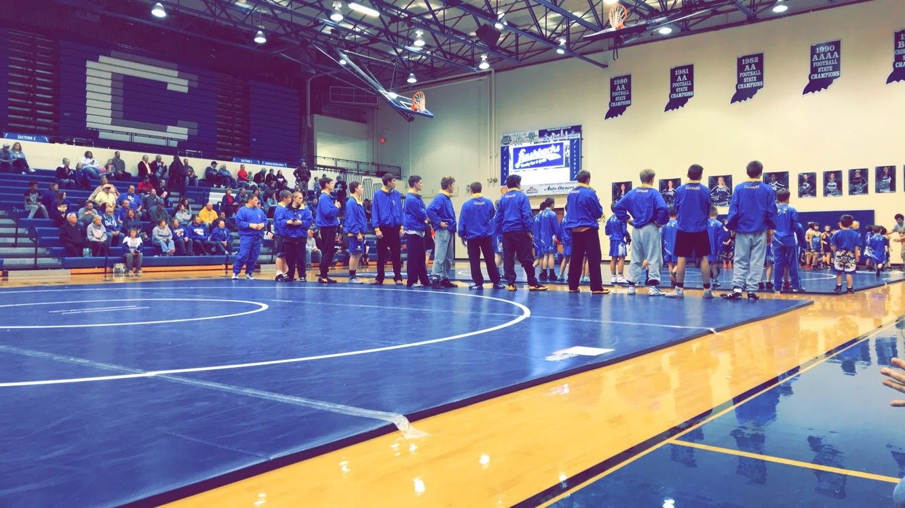
WHERE: GREENFIELD-CENTRAL HIGH SCHOOL’S MAIN GYM !!
WHEN: Saturday, November 16th, 2019 @ 6:00 PM !!
COST: FREE !!
