Benefit Day

at

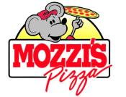

2221 W. Main St. Greenfield 317-462-2999

1282 N. State St. Greenfield 317-462-3005

for

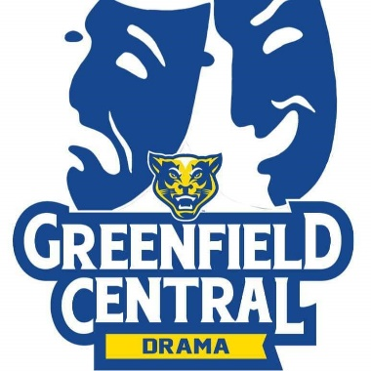

on

February 5, 2020

When paying for your purchase, present this flyer and Mozzi’s Pizza will donate 20% of your purchase to

G-C Drama Booster Club.