Registration form
Name_______________________ Print please
Age:_______ Grade in fall____
Address:___________________________
City:_______________________Zip_____
Which camp? Curriculum will differ.
____June 17-20: Animal Lovers and More
____July 15-18: Wings and Things
Emergency contact number________________
Parent Email address: _____________________________________
________*Total Fee enclosed or
________Down payment enclosed ($20), balance due first day of camp
*$80 for one or $150 for two, i.e. $75 each
Add an additional camper?
_________________________age_____
Email address______________________
Due by June 12 Session I or July10 Session II
Send to: Sandy Hall % Art camp
66 W. Michigan, Greenfield IN 46140

Meet on first level
Bring what supplies you may have in a backpack or bag: pencil, eraser, sketchbook, watercolor paints, and brushes. I will have extra supplies at no additional charge.
June 17-20
Or
July 15-18
2013
Monday-Thursday=$80 for one
If two sign up together=$150 for two, save $10
Questions? Email me at sandyhall68@sbcglobal.net
Or call 317-462-1968
leave message with Roger.

Students may be asked to cross the street to draw gargoyles or architectural elements. Safety precautions will be established and students will be asked to follow the rules. Alert me if your child has any food or latex allergies.
Copy and share this brochure with others.

Express yourself
Art Smart
Summer Camps
2013
Led by Sandy Hall, Studio 12A
June 17-20
July 15-18
Creative Arts and Event Center
2 W. Main St
Greenfield IN 46160

2 p.m. - 4 p.m. daily
Monday-Thursday
Ages 5-12
Meet the Artist
Sandy Hall, Studio 12A
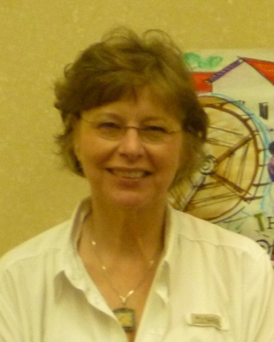
This is her 3rd year to run “ART SMART” camps at the Arts Center. She has donated her time to create art in the community with her Art Club, Relay for Life, Nameless Creek Youth camp and the Riley Festival. She has received numerous ribbons for plein air painting events and local festivals. She has participated in “The Artists Upstairs” 2nd Friday initiatives through the Creative Arts and Event Center since 2008.
She holds degrees in Art and Math Education from Purdue University and a Masters degree from IUPUI in secondary education. Newly retired, Sandy taught art to many students in the Greenfield Central Schools.
A Lilly Endowment Teacher Creativity grant recipient, she traveled to Mexico last June to study the art of ceramic tile painting. She designed a clay sculpture and painted acrylic floor cloths. In 2004 she went to China to create inlaid glass panels. And in 1995, she studied printmaking in Sendai, Japan.
This camp is designed for ages five through twelve. If numbers run high, a 9 am-11 am session will be offered.
Activities are designed to allow students to discover new ways to express themselves by using media. Problem solving within the creative process is encouraged. Getting an end product is an added reward.
“It is my goal to make ART fun and exciting. Your child will be encouraged to express ideas, to experiment with shapes, colors and lines. This is an “ART SMART” camp with plenty of techniques to explore. Campers will leave with a wealth of fresh approaches to make art happen. If they sign up with a sibling or friend, the price is lowered. Supplies will be available to manipulate. Bring a sketchbook, pencil, eraser, watercolors, colored pencils, and markers if you have them. Have a special image, sketches or photo you wish to work from? Bring those too.”

Parents will be asked to sign an optional release form the first day of camp. Signed form will give instructor permission to take photos of activities and students for publicity and news articles.
Photos of camper creations will be featured during second Friday,
August 9
6-9 pm, 2nd floor
Creative Arts and Event Center
2 pm- 4 pm Monday-Thursday
Snacks will be served. Let Sandy know if your child has any food allergies or food limitations.
Public parking is located to the west of the Chris Sickels’ mural. Also there is parking on North Street. Please pick your child up promptly by 4:15.

